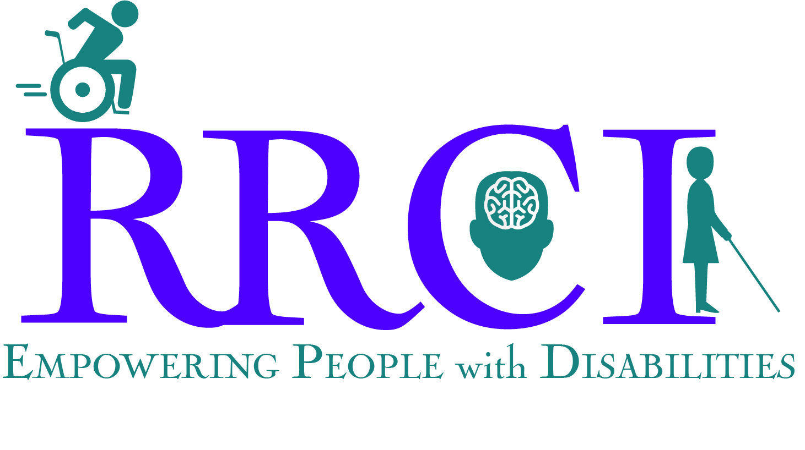
Consumer Policy Manual
Approved by RRCI Board of Directors
Initial: 03/2016, 04/2016, 09/2019

PREFACE
Welcome to Red Rock Center for Independence!
We look forward to helping consumers meet their goals for independent living. People with disabilities are valuable members of our community and we appreciate when they turn to RRCI for empowerment.
This manual is designed to answer any questions consumers may have about Red Rock Center for Independence. Although we have tried to include policies related to frequent consumer concerns, this manual is subject to change without notice.
Our Mission: To empower people with disabilities in southwestern Utah to live independently through education, personalized services, and technology.
Our Vision: Red Rock Center for Independence envisions individuals with disabilities in southwestern Utah will achieve their maximum level of independence with full inclusion across all environments.
We Value:
Individual Rights: People with disabilities will have and exercise the same rights as everyone else.

Consumer-Focused Services: Ensure that resources, services, and programs are focused on successfully responding to and meeting the needs of consumers.

Dedication: Staff and consumers actively participate in training and education and demonstrate values of integrity, empathy, compassion, and engagement.

Community Relations: Consumers, community and staff recognize, understand, and respect the professional services and mission of RRCI.

Our Purpose:

To promote a philosophy of independent living, including a philosophy of consumer control, peer support, self-help, self-determination, equal access, and individual and system advocacy, in order to maximize the leadership, empowerment, independence, and productivity of individuals with disabilities, and the integration and full inclusion of individuals with disabilities into the mainstream of American society. The term “consumer control” means, with respect to RRCI, that the Center vests power and authority in individuals with disabilities, in terms of management, staffing, decision making, operation, and provision of services, of the Red Rock Center for Independence.

TABLE OF CONTENTS
PREFACE 1
GENERAL PROVISIONS 3
OPEN FOR BUSINESS AND HOLIDAYS 4
CONSUMER ACTIVITIES AND AGE 5
TRANSPORTATION 6
SERVICE/EMOTIONAL SUPPORT ANIMALS 7
CONSUMER CONFIDENTIALITY AND TREATMENT 8
DISTRIBUTION OF VOUCHER FUNDS 9
CONSUMER GRIEVANCE POLICY 10
SUBSTANCE ABUSE 11
FRAGRANCE FREE ENVIRONMENT POLICY 12
ASSISTIVE TECHNOLOGY LOAN BANK RESPONSIBILITIES 13
DONATING TO RED ROCK CENTER FOR INDEPENDENCE 14
RECIEPT OF THE CONSUMER POLICY MANUAL 15

GENERAL PROVISIONS
Red Rock Center for Independence does not discriminate on the basis of race, gender, age, politics, disability, religion, color, sex, sexual orientation, age, national origin, or any other class protected by State or Federal law.
Authority for administering these policies is vested by the Board of Directors for RRCI to the Executive Director. The Board of Directors employs the Executive Director. The Executive Director has authority over all operations of RRCI.
The Executive Director and the Board of Directors for RRCI will review these policies and procedures as needed. Revisions to the Manual must be approved by RRCI Board of Directors.

OPEN FOR BUSINESS AND HOLIDAYS
RRCI is open for business from 8:00 a.m. until 5:00 p.m. Monday through Friday. Staff members are required to take a one hour lunch break each day. Additionally, staff members earn leave time and are required to take time off periodically throughout the year. Should a consumer need an appointment with a staff member, please call in advance to ensure he or she is in the office and available. Periodically, the office will be closed for staff training and other meetings.
RRCI shall be closed for business during the following holidays:
New Year’s Day (January 1)
Martin Luther King Day (3rd Monday in January)
President’s Day (3rd Monday in February)
Memorial Day (last Monday in May)
Independence Day (July 4th)
Pioneer Day (July 24th)
Labor Day (1st Monday in September)
Columbus Day (2nd Monday in October)
Veteran’s Day (November 11th)
Thanksgiving Day (4th Thursday and Friday in November)
Christmas Day (December 25th)
When a holiday listed in Paragraph A falls on a Saturday, the preceding Friday shall be recognized as the Holiday. When a holiday listed in Paragraph A falls on a Sunday, the following Monday shall be recognized as the holiday.

CONSUMER ACTIVITIES AND AGE
All activities provided by RRCI are expressly voluntary. Consumers may be invited to attend various activities and events, but they are not required to attend.
All activities may not be appropriate for consumers of all ages. Some activities, including peer mentoring groups may contain subjects sensitive in nature and may be exclusive to individuals who are specific to that group or activity. Protecting the privacy of the consumers and ensuring the safety of the older and younger youth is a primary responsibility of RRCI. RRCI asks that consumers understand that this age restriction is not discrimination and is for the benefit of those participating in the activity.
RRCI posts a calendar of events with notification of appropriate age and demographic participation. Consumers will be advised regarding age guidelines upon invitation or noted on the calendar at www.rrci.org.

TRANSPORTATION
RRCI has limited transportation. Consumers are expected to provide their own transportation or use public transportation to visit with staff or attend an activity.
If a consumer is unable to arrange transportation independently, they may call RRCI and request transportation services. RRCI requires at least 24 hours advanced notice of transportation requests. Transportation will be provided on a first come, first served basis.
Consumers are responsible for cancelling a ride at least three (3) hours before a scheduled ride. Should consumer fail to notify RRCI of a ride cancellation, the following consequences will occur:
1. Warning
2. Consumer will not be able to access transportation services for the next two opportunities.

SERVICE/EMOTIONAL SUPPORT ANIMALS
SERVICE ANIMALS: *Under the ADA, a service animal is defined as a dog that has been individually trained to do work or perform tasks for an individual with a disability. The task(s) performed by the dog must be directly related to the person's disability.

*The ADA requires that service animals be under the control of the handler at all times.

*The service animal must be harnessed, leashed, or tethered while in public places unless these devices interfere with the service animal's work or the person's disability prevents use of these devices. In that case, the person must use voice, signal, or other effective means to maintain control of the animal.

**If a service animal is out of control and the handler does not take effective action to control it, staff may request that the animal be removed from the premises.

EMOTIONAL SUPPORT ANIMALS: *Emotional support animals provide comfort just by being with a person. Because they have not been trained to perform a specific job or task, they do not qualify as service animals under the ADA.

**RRCI encourages consumers who visit RRCI to connect emotionally with their peers. Emotional support animals are not service animals and do not support the atmosphere of comradery that RRCI promotes. Except for special circumstances, emotional support animals may not accompany their owners at RRCI activities and meetings.

**RRCI prohibits consumers from encouraging children or others to come in proximity of an animal.

* Retrieved from www.ada.gov on 9/21/2015 **RRCI Policy

CONSUMER CONFIDENTIALITY AND TREATMENT
All employees of RRCI shall assure that confidentiality of consumer information is maintained at all times. Information in any format in reference to the individual is filed in the Consumer Service Record (CSR) established under his/her name. Current CSR’s are maintained in the locking file cabinet or secured computer designated for that purpose.
RRCI staff are required to honor consumer confidentiality.
A staff member who has reason to suspect that a consumer is being abused is required to report all suspicions to the proper authority.

DISTRIBUTION OF VOUCHER FUNDS

At times, RRCI receives a grant for vouchers that consumers can spend at the granting facility. Vouchers may come from Deseret Industries (DI) or other community providers. The grants are limited and are received one time each year. RRCI is responsible to distribute the vouchers conservatively and distribution is based on consumer need.
It is the policy of RRCI to manage the funds carefully so that consumers with the highest and most immediate needs are served. Vouchers are only used to provide necessities that facilitate independence and support the consumers goals. The voucher will not be distributed for luxuries, supplemental household items, clothing items.
RRCI has identified the following limits on voucher requests per grant cycle (one time each year):

An individual transitioning from an institution: Based on level of need
An individual: Up to: $150
Family of two: Up to: $250
Family of three or more: Up to: $350

The procedure to receive a voucher will be explained by your IL Coordinator.
If a consumer deviates from the agreed upon purchase with the voucher, RRCI will report the variance to the granting authority. And, future vouchers will be denied.

CONSUMER GRIEVANCE POLICY
Consumers with concerns regarding their treatment, service delivery, discrimination, or any issue that raises concern are encouraged to discuss the matter with their assigned Independent Living Coordinator.
Should the concern be about the coordinator, the consumer should discuss the matter with the Independent Living Coordinator Supervisor.
If the matter is not resolved, the Independent Living Supervisor will discuss the matter with the Executive Director.
Consumers are to receive the Client Assistance Program (CAP) brochure and Consumer rights information at least annually starting with the Initial intake and whenever an Independent Living Plan (ILP) is developed or updated. The CAP brochure is available at any time a consumer has concerns regarding their treatment, service delivery, discrimination, or any issue that raises concern. The CAP part is “The disability law center/client assistance program (CAP) is available to act as your advisor and advocate at any time. Call toll free 1-800-662-9080 or Salt Lake City 801-363-1347, 205 North 400 West Salt Lake City, UT 84103.”
If a consumer is concerned about fraud, waste, or abuse regarding RRCI’sfinancial management, he or she should bring the concern directly to the executive director. If the concern is about the executive director, the consumer should consult his or her Independent Living Coordinator about the appropriate reporting procedure.
Consumers are to be encouraged to follow recommendations for self-advocacy.

SUBSTANCE ABUSE
It is the policy of RRCI to maintain a drug free environment.
The following substances are considered drugs:
Alcohol, Illicit drugs, that is, substances governed by the Federal Controlled Substance Acts.
Legal drugs used improperly.
Non-drug substances such as glue, solvents, etc., used improperly.
Any use of drugs while on RRCI property or while a consumer is involved in an RRCI sponsored activity is strictly prohibited.
Should a consumer be suspected of drug use prior to, or during an activity, in an RRCI vehicle, or on the premises, he or she will be asked to leave immediately. If the consumer refuse to leave, law enforcement will be called.

FRAGRANCE FREE ENVIRONMENT POLICY
Employees and visitors to our organization may have sensitivity and/or allergic reactions to various fragrant products. Therefore, RRCI is a fragrance-free workplace. Personal products (fragrances, colognes, lotions, powders, deodorants, shaving and hair products, and other similar items) that are perceptible to others should not be worn by employees. Other fragrant products (scented candles, potpourri and similar items) are also not permitted in the workplace.

Any consumer with a concern about scents or odors should contact his or her Independent Living Coordinator.

ASSISTIVE TECHNOLOGY LOAN BANK RESPONSIBILITIES
Equipment loaned from the Loan Bank is provided on a temporary basis. The typical usage period for equipment is two to four weeks. This period can be extended according to need, if deemed necessary by your Independent Living Coordinator.

The equipment may be recalled by staff at any time and must be returned within 24 hours.

The borrower is financially responsible for the repair of any damages to the equipment during the loan period.

If the equipment is lost or stolen during the loan period, the borrower is financially responsible for the replacement of an equivalent piece of equipment.

RRCI staff will take a photo of each piece of loaned equipment with the Loan Agreement attached. The photo will be kept in a secure database. Should a piece of equipment be misused or abused, a second piece of equipment will not be loaned.

RRCI is not liable for any accident or harm incurred with the use of this equipment.

Borrowers are required to return the equipment by the agreed upon due date.

Although there is no fee to use a loan bank item, RRCI requests that the borrower make a minimum $5 donation for the maintenance and repairs of the item(s) being borrowed.

DONATING TO RED ROCK CENTER FOR INDEPENDENCE
I understand that most of the services that I may receive from RRCI are at no cost. Funding for these services come from federal and state contracts, grants, and from donations by consumers and community members who appreciate the work that the Center does.

RRCI offers a monthly donation opportunity to all members of the community called, “I AM ABLE!”

A $2 per month donation helps a child with disabilities have the needed supplies for a socialization activity
A $12 per month donation helps the Center provide a round trip ride to one consumer to a life skills training class
A $20 per month donation helps repair a mobility device so a consumer can access the community

There is no minimum or maximum gift. People chose to give at a level they are comfortable with.

I AM ABLE! I would like to donate to Red Rock Center for Independence. I can call the Center to set up my monthly donation through my bank account or through a credit card.

Red Rock Center for Independence appreciates donations of gently used equipment that may help someone in need.

RECIEPT OF THE CONSUMER POLICY MANUAL
I have received this Consumer Policy Manual. My Independent Living Coordinator has reviewed this manual with me during the development of my Independent Living Plan or at my Annual Review.
I can ask for this manual in an accessible format.
I understand that I am responsible to ask more questions if I need help with the document.
I will sign this form acknowledging that I have received a copy of this Manual. It will be placed in my file. I will be informed of changes to the manual each year, during my annual review. A new copy of this form will be placed in my file.
I have received and reviewed this manual and know that I can use it as a resource as a consumer of Red Rock Center for Independence.

Signed: _____________________________________

Date: ___________________

