Dear Community Partner,

Help RRCI empower people with disabilities by becoming a sponsor of the 3nd Annual Fun Run, DoNut Dash 5K.

The 5K is a family event scheduled for the morning of Saturday, March 30, 2019 at Crosby Confluence Park (near the St. George Convention Center). People from all over Southwestern Utah attended last year's event and this year promises to be even better!

Your generous sponsorship will assist RRCI's work to empower people with disabilities by delivering programs to people of all ages and disabilities and their families that include:

- Independent Living Skills Training and Opportunities
- Peer to Peer Support
- Information and Referral Services
- Youth Programs and Nursing Home Transition
- Self-Advocacy and Systems Advocacy Training and Support
- Older Blind Programs
- Mobility and Technology Needs; Home Repairs and Modification
- Family Respite
- And so much more!

Any generous donation is gratefully accepted! Please consider giving at one of the sponsorship levels included on the attached page.

Sincerely,
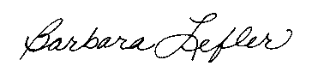
Barbara Lefler, Executive Director
RRCI (formerly Red Rock Center for Independence)

P.S. Form a team and enjoy the event with fellow employees, friends, family, and neighbors! See our website (www.rrci.org) to sign up.

