January 2019
Executive Directors Report
Accident Report
On December 4th, 2018 there was an accident that took place in the parking lot of our building. Tracy Mc Donald was attending a meeting for the National Federation for the Blind that is held at our office. When leaving to go back to the bus stop, she somehow got turned around and fell from the parking lot above our building to the parking lot of our building.
The owners of both buildings came to our office inquiring as to what happened. They had both been named in a lawsuit filed by Mrs. Mc Donald. To assure that we were handling the issue correctly, Barb called the Non-Profit Legal Services so seek their council. They advised her to notify RRCI’s liability insurance.
Brenda Adair called Jaron Hunt at The Leavitt Group. He informed her that since RRCI was not specifically named in the law suit, he felt things would be fine. He instructed Brenda to compose an email to be sent to him that included the known details of the accident including statements from those in the office that were involved. He will hold it on file in case a claim does need to be made. Brenda has done as instructed.
Building Update
Less than $1000 has been raised to date. Greg will be working on other marketing strategies with his contacts and will be requesting some funds returned from Keystone to pay for the new direction.

Christmas Onetime Merit Increase: Staff was most appreciative.

Staff Training
The staff met at Barb’s home to review and rejuvenate our values. It was a very positive meeting and we all walked way with good support for one another.

RRCI= VITA Site: RRCI collaborates with Five County Association of Governments by opening our facility to members of the community for free tax service. Our consumers and others benefit from this community service at a convenient location. February 1st-April 15th.

New Mini Van
With the passing of the 1992 Gold Mazda Van, RRCI was informed about a 2004 Gold Toyota Sienna Van as a replacement. The Finance Committee approved of the purchase. This has helped with consumer transportation to RRCI activities.

Chamber/UNA Meeting:
December 4, 2018, RRCI was represented at a joint community meeting. However, the Chamber booked a conflict and it was not well attended by the business community.

Larger Space in Cedar:
The building where RRCI office is currently located in Cedar City has available space that would be adequate for our needs. It would increase rent by $175 per month. Something to consider based on need.

Executive Director Health
Barb has been diagnosed with Ductal Cell Carcinoma, a form of breast cancer. Treatment begins on January 11, 2019. The doctor anticipates full cure. Although she will be missing some work, she has plenty of leave time built up. She plans to be to work every week although some weeks will be more limited due to treatment. Your continued support is most appreciated.

Consumer Surveys
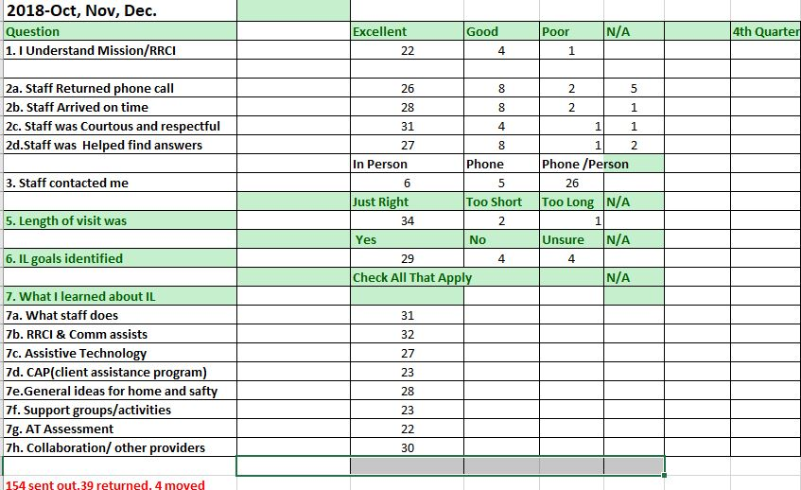
Written Comments:
QUESTION 9---HOW DID STAFF HELP YOU THE MOST?
- She came to my house and helped us.
- Giving me about RRCI helping with my needs, with and for my disabilities and getting
- for or repairing with walkers, wheelchair batteries for my chair with parts and repairs on my assistive with equipment needs. Just all and any requests and help that I’ve needed RRCI is great.
- Helped with getting a wheelie walker for my husband.
- Information
- They are like my family we all support each other and help each other when we need it. Helped me with looking for jobs and just being there for me when I need it.
- With my mobility
- Provided wheel chair for me. Replaced my old ramp, so I can continue going outside
- I have a reclining bed. I had a reclining chair, but broke and never got another. Helped with hearing aids. Handles for my bath room.
- Community Block Grant funded remodeling of my kitchen to make it accessible. Also, I tried a loan closet scooter. I liked the loan closet scooter so well that I used my own money to purchase my first mobility scooter.
- Staff gave me numbers to call for work.
- We go to activities
- Finding activities outside and attending cooking class at the centers and other activities there. Loved when Brenda’s father came and put on a slide program
- With things I needed to be more comfortable at home and not in a home
- General information
QUESTION 10----HOW CAN RRCI IMPROVE OUR SERVICES TO HELP YOU MORE EFFECTIVELY?
- I am not sure
- They do all they can with the funds they get. It’s a shame that whoever/whatever provides their funding doesn’t allow them more funds to help as there are a lot of people now living longer and needing help. RRCI does the best with what they have to help us with.
- I would love to continue to work with them and hoping to do more there.
- They are doing a great job.
- I don’t know.
- Continue to do a great job.
- Helping work on checking on hearing aids
- Helping work on a new mattress.
- Keep more informed on activities and be reachable when need.
- Kind of take a long time to get some things like if you need a wheel chair 1 year waiting is two long when you are bad off you need it now falling down just makes you more disabled.
- Not sure
QUESTION 11.---PLEASE SHARE ANY OTHER THOUGHTS YOU MAY HAVE ABOUT YOUR EXPERIENCE WITH RRCI AND STAFF?
- I thought they were helpful.
- The staff and crew there are very helpful and caring for their clients and I hope they will be there always, not only for me, but for all the people like me that need their help. I have given RRCI one 3 wheeled scooter I had to help someone else that cannot walk or breathe well due to heart and lung diseases and when I die I’ve asked my family to give all the pieces of medical equipment I have obtained over a few years. I give all my thanks to Timothy Leslie and Mike! Keep up the excellent work guys!! You’re great. Yours Truly Ruby Presley
- Nice people to work with
- I love them all!!
- Very nice and helpful
- Thank you for all your help. Always Thanks
- RRCI staff are friendly and helpful.
- none
- Experience has been great, staff is excellent.

