**Community Connections**

I have reached out to Honorable Corrina Bow who is the president of the Piute tribe. We are trying to service any consumers who may need assistance and could benefit from our services in their community.

I have also reached out to Lucia Taylor. Lucia is the chair of the Spanish department at Utah Tech University. We have asked if any of their staff or students would be interesting in volunteering as translators so we can better assist Spanish speaking consumers. It is our intention to reach out to some of the churches in the local community to help their Spanish speaking members get services.

The week of 1/23 through 1/27 I will be in SLC at the capital at the request of Noreen Roeca (the Independent Living Counselor for Utah). We will be meeting with the Disability Advocates, the AILU, LCPD, Social Services, the Utah Legislature and doing trainings with USILC and advocacy training as well as working with the other non-profit independent living organizations in Utah.

Scott Buys of Five County Association asked if I would join his subcommittee on Sensitivity Awareness and help with starting that new committee.

**New Program**

We are starting a new program for Older Youth Autistic individuals. We have found that due to having lack of interest in activities for older youth due to the simplicity of the exercises (because of the wide variety of disabilities in the group) we needed to have one designed to help those who need people skills and interaction that would benefit those with autism. We are hoping to start in February and plan to have one activity a month to start.

**Obstacles**

The governor’s budget did not have an increase for CIL’s. Our insurance increased 12% and our rent in Hurricane increased by $70 a month. As our other contracts come up, we will probably have more increases. We have tried to offset some of things by cutting unnecessary memberships and expenditures.

**Phone surveys**

The last mail survey that was sent out had about a 10 percent response. We decided to cut costs in envelopes, postage, and paper by having the IL’s make calls (which they do to check on the consumer’s anyway) and ask if they would do a phone survey. We have our non-IL staff do the phone survey so the consumer can be more comfortable with communicating any issues. We have gotten a good response so far, especially from the low vision group as many wouldn’t have filled out the mailed form due to their disability.

**Leadership Team created**

In order to organize the flow of information and staff inquiries about issues a leadership team was established. All IT and office paperwork will go through Matina, all IL questions will go through Tim, Q90, networking and training will go through our specialist Brenda and all community integration will go through Jamie.

We meet once a month and discuss and problem solve any issues. This allows staff members with disabilities to be part of the decision-making process.

**Employee of the Month**

I want to recognize individuals who are team players and do a good job. Once a month our Leadership team will decide on an employee who is deserving, and we will present them with a certificate and if the board and budget allows a gift certificate from Swig or another place.

**St. George Chamber of Commerce**

The Chamber is going to send a Donut Dash Flyer and the sponsorship application out with their email. This will go out to approximately 900 members.

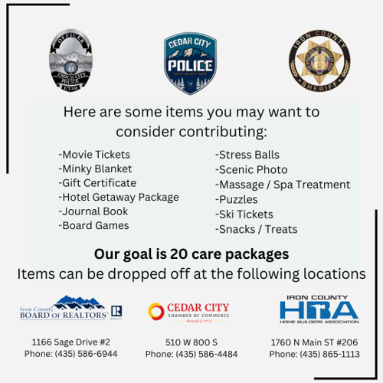

**RRCI consumer driven package**

We are currently putting together a care package for the Police officer who is suffering from PTSD in Enoch.

Besides some of the things we have here to give (stress ball, consumer made blanket etc.) Valeria is going to have her

Independent Living cooking class make cookies and a trail mix to give. We wanted

the officers to get something that our consumer’s created so that it was more

meaningful to them.